

Programme Name: ________**BCS HONS**_______________________________________

Course Code: __**CSC 2516**________

Course Name: _______**Data Structure and Algorithm**_____________________________

**Assignment** / Lab Sheet / Project / Case Study No. _**2**___

Date of Submission: ______**8/10/2021**_____________

**Submitted By: Submitted To:**

Student Name**: Dipesh Tha Shrestha** Faculty Name**: Prakash Chandra Sir**

IUKL ID: **041902900028** Department**: LMS**

Semester**: Fourth Semester**

Intake**: September 2019**

**1.**

**a) Explain the concept of Linked List and advantages of Linked list over arrays.**

**Answer:** A linked list is a linear data structure that includes a series of connected nodes. Here, each node stores the **data** and the **address** of the next node.

Advantage of a linked list over array is that, we can add any number of elements in the list, this is not possible in case of an array. Linked list provide an efficient way of storing related data and perform basic operations such as insertion, deletion and updating of information at the cost of extra space required for storing the address.

**b) Write C program to implement: Insert, delete, search and display operations in singly linked list**

**Answer:** C program to implement: Insert, delete, search and display operations in singly linked list is given below:

// program to implement insert, delete, search and display singly linked list

#include<stdio.h>

#include<stdlib.h>

*struct* node{

*int* data;

*struct* node *next;

};

*struct* node *head=NULL;

*void* insert_at_begining()

{

*struct* node *ptr;

*int* item;

    ptr = (*struct* node*)malloc(sizeof(*struct* node));

    if (ptr==NULL)

    {

        printf("\noverflow\n");

    }

    else

    {

        printf("\nEnter element to insert: ");

        scanf("%d", &item);

        ptr->data=item;

        ptr->next=NULL;

        if(head!=NULL)

        {

            ptr->next=head;

            head=ptr;

        }

        else{

        head=ptr;

        }

    }

}

*void* insert_at_pos()

{

*struct* node *ptr;

*struct* node *temp;

*int* item, i=1, pos;

    ptr = (*struct* node*)malloc(sizeof(*struct* node));

    if (ptr==NULL)

    {

        printf("\noverflow\n");

    }

    else

    {

        printf("\nEnter element to be inserted: ");

        scanf("%d", &item);

        ptr->data=item;

        ptr->next=NULL;

        printf("\nEnter position to be inserted:");

        scanf("%d",&pos);

        while (i<pos-1)

        {

            temp= temp->next;

            i++;

        }

        ptr->next = temp->next;

        temp->next = ptr;

    }

}

*void* insert_at_end()

{

*struct* node *ptr;

*struct* node *temp;

*int* item;

    ptr = (*struct* node*)malloc(sizeof(*struct* node));

    if (ptr==NULL)

    {

        printf("\noverflow\n");

    }

    else

    {

        printf("\nEnter element to insert at last: ");

        scanf("%d", &item);

        ptr->data=item;

        ptr->next=NULL;

        temp=head;

        while(temp->next!=NULL)

        {

            temp = temp->next;

        }

        temp->next = ptr;

        ptr->next = NULL;

    }

}

*void* delete_from_begining()

{

*struct* node *temp;

*struct* node *ptr;

   if (head == NULL)

   {

      printf("\nUnderflow\n");

   }

   else

   {

      ptr = head;

      temp = ptr->next;

      head = temp;

      free(ptr);

      printf("\nFirst node deleted successfully\n");

   }

}

*void* delete_from_pos()

{

*struct* node *ptr;

*struct* node *temp;

*int* i=1, pos;

    ptr = (*struct* node*)malloc(sizeof(*struct* node));

    if (ptr==NULL)

    {

        printf("\noverflow\n");

    }

    else

    {

        printf("\nEnter the position: ");

        scanf("%d", &pos);

        temp = head;

        while(i<pos-1)

        {

            i++;

            temp = temp->next;

        }

        ptr = temp->next;

        temp->next = ptr->next;

        free(ptr);

        printf("\n Node deleted successfully\n");

    }

}

*void* delete_from_end()

{

*struct* node *temp;

*struct* node *ptr;

    if(head==NULL)

    {

        printf("\nUnderflow\n");

    }

    else

    {

        temp = head;

        while(temp->next->next!=NULL)

        {

            temp = temp->next;

        }

        ptr = temp->next->next;

        temp->next = NULL;

        free(ptr);

        printf("\n Node deleted successfully\n");

    }

}

*void* display()

{

*struct* node *temp;

    temp = head;

    printf("\nThe list contains following data:\n");

    while(temp!=NULL)

    {

        printf("%d\t",temp->data);

        temp = temp->next;

    }

}

*void* search()

{

*struct* node *temp;

*int* key;

*int* i=1;

    if(head!=NULL)

    {

        printf("\nEnter the key to be searched: ");

        scanf("%d",&key);

        temp = head;

        while(temp!=NULL)

        {

            if(temp->data==key)

            {

                printf("\n%d is found at pos: %d\n",key,i);

                break;

            }

            i++;

            temp = temp->next;

        }

    }

    else

    {

        printf("\nlist is empty\n");

    }

}

*int* main()

{

    insert_at_begining();

    insert_at_pos();

    insert_at_pos();

    insert_at_end();

    search();

    delete_from_begining();

    delete_from_pos();

    delete_from_end();

    display();

}

**Output;**

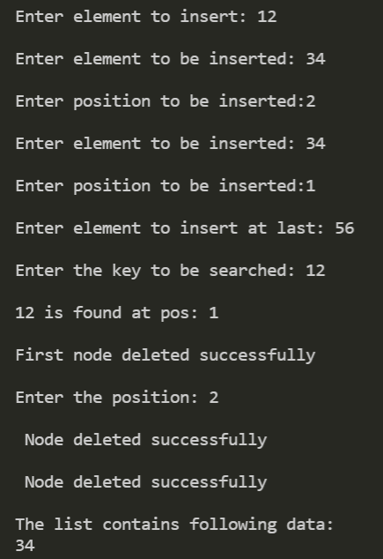

**2. Using STACK, convert the following infix expression into postfix expression:**

**a) (A+B)*C-(D-E)*(F+G)**

**NOTE: use tables with proper heading and descriptions**

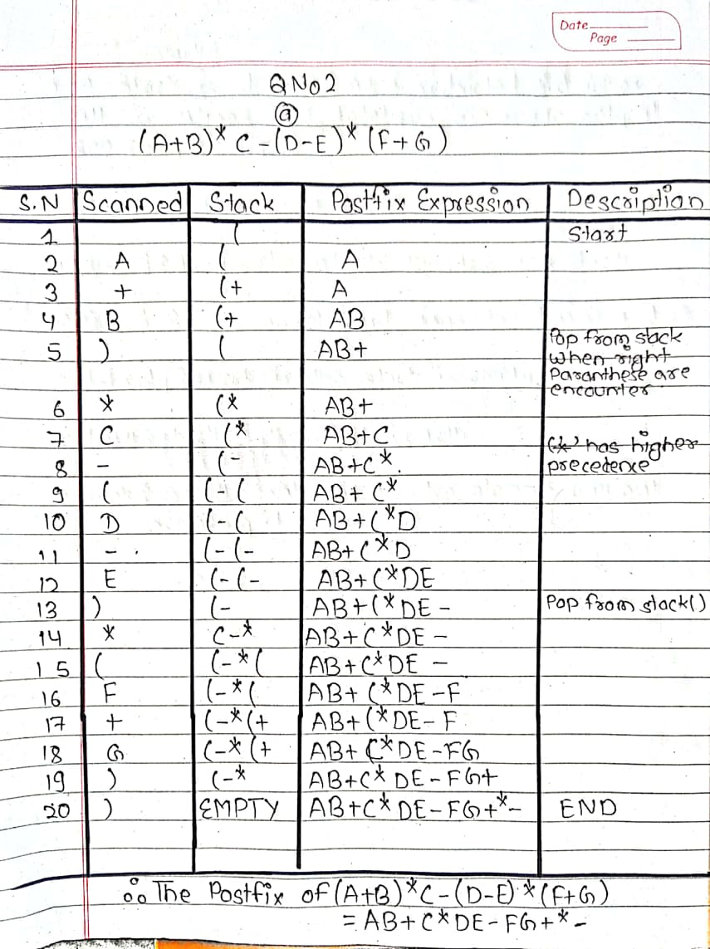

**3. a) List real world applications of doubly linked lists**

Answer: The real world applications of doubly linked lists are as follow:

* It is used by browsers to implement backward and forward navigation of visited web pages i.e. back and forward button.
* It is also used by various applications to implement Undo and Redo functionality.
* It can also be used to represent deck of cards in games.
* It is also used to represent various states of a game.
* It can be used in navigation systems where both front and back navigation is required.

**b) Write a C program to implement queue data structure using linked lists.**

**Answer:** C program to implement queue data structure using linked listsare given below:

// implementation of queue using linked list

#include <stdio.h>

#include <stdlib.h>

*struct* node{

*int* data;

*struct* node *next;

};

*struct* node *front=NULL, *rear=NULL;

*void* enqueue()

{

*struct* node *ptr,*temp;

*int* data;

    ptr = (*struct* node*)malloc (sizeof(*struct* node));

    if (ptr==NULL)

    {

        printf("\noverflow\n");

    }

    else

    {

        printf("\nEnter the data to be inserted into Q:\n");

        scanf("%d", &data);

        ptr->data = data;

        ptr->next = NULL;

        if (front==NULL && rear==NULL)

        {

            front=ptr;

            rear=ptr;

        }

        else

        {

            temp=rear;

            temp->next = ptr;

            rear = ptr;

        }

    }

}

*void* dequeue()

{

*struct* node *temp;

    if (front==NULL)

    {

        printf("\nQueue is empty:underflow\n");

    }

    else

    {

        if (front!=rear)

        {

            temp = front;

            front = temp->next;

            free(temp);

        }

        else

        {

            temp = front;

            front = NULL;

            rear = NULL;

            free (temp);

        }

    }

}

*void* display()

{

*struct* node *temp;

    if (front==NULL && rear==NULL)

    {

        printf("\nQueue is empty\n");

    }

    else

    {

        temp = front;

        printf("\nThe queue contains following elements:\n");

        while(temp!=NULL)

        {

            printf("%d\t",temp->data);

            temp = temp->next;

        }

    }

}

*void* main()

{

*int* choice;

*char* ch='y';

    while(ch=='y')

    {

        printf("\nCHOOSE 1:Enqueue 2:Dequeue 3:Display\n");

        scanf("%d",&choice);

        switch(choice)

        {

            case 1:

                enqueue();

                break;

            case 2:

                dequeue();

                break;

            case 3:

                display();

                break;

            default:

                printf("\nInvalid Choice\n");

                break;

        getchar();

        printf("\ndo you want to continue(y/n)");

        scanf("%c",&ch);

    }

}

**Output:**

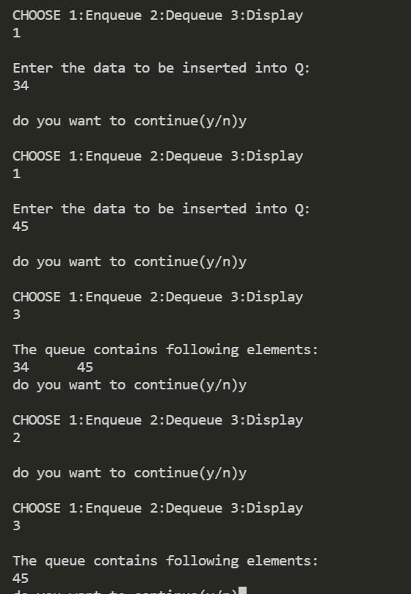

**Thank you**